# PRACTICAL – 2

**2.1 AIM: Bubble Sort**

**PROGRAM CODE**:

#include <iostream> using namespace std; int counter = 0;

void bubbleSort(int arr[], int size)

{

int temp;

for (int i = 0; i < size; i++)

{

for (int j = 0; j < size - i - 1; j++)

{

if (arr[j] > arr[j + 1])

{

temp = arr[j]; arr[j] = arr[j + 1]; arr[j + 1] = temp; counter++;

}

}

}

}

int main()

{

int n;

cout << "Enter the size of array: "; cin >> n;

int arr[n]; cout << endl

<< "Enter the array elements: "; for (int i = 0; i < n; i++)

{

cin >> arr[i];

}

bubbleSort(arr, n); cout << endl

<< "The sorted array is: "; for (int i = 0; i < n; i++)

cout << arr[i] << " "; cout << endl

<< "Counter: " << counter << endl; cout << "\n20DCE019-Yatharth Chauhan";

}

**OUTPUT**:

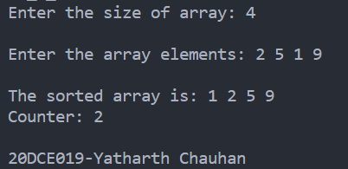

**2.2 AIM: Selection Sort**

**PROGRAM CODE**:

#include <iostream> using namespace std; int counter = 0;

void selectionSort(int arr[], int size)

{

int temp;

int min_index = 0;

for (int i = 0; i < size; i++)

{

min_index = i;

for (int j = i; j < size; j++)

{

if (arr[min_index] > arr[j])

{

min_index = j;

}

}

temp = arr[i];

arr[i] = arr[min_index]; arr[min_index] = temp; counter++;

}

}

int main()

{

int n;

cout << "\nEnter size of array: "; cin >> n;

int arr[n];

cout << "Enter array elements: "; for (int i = 0; i < n; i++)

cin >> arr[i]; selectionSort(arr, n); cout << endl

<< "Sorted array is: "; for (int i = 0; i < n; i++)

cout << arr[i] << " "; cout << endl

<< "Counter: " << counter << endl; cout << "\n20DCE019-Yatharth Chauhan";

}

**OUTPUT:**

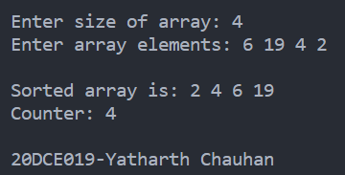

**2.3 AIM: Insertion Sort**

**PROGRAM CODE**:

#include <iostream> using namespace std; int counter = 0;

void insertionSort(int arr[], int size)

{

int temp;

for (int i = 0; i < size - 1; i++)

{

for (int j = i + 1; j > 0; j--)

{

if (arr[j] < arr[j - 1])

{

temp = arr[j]; arr[j] = arr[j - 1]; arr[j - 1] = temp; counter++;

}

}

}

}

int main()

{

int n;

cout << "\nEnter the size of the array: "; cin >> n;

int arr[n]; cout << endl

<< "Please enter the array elements: "; for (int i = 0; i < n; i++)

cin >> arr[i]; insertionSort(arr, n);

cout << endl

<< "The sorted array is: " << endl; for (int i = 0; i < n; i++)

cout << arr[i] << " "; cout << endl

<< "Counter: " << counter << endl; cout << "\n20DCE019-Yatharth Chauhan"; return 0;

}

**OUTPUT**:

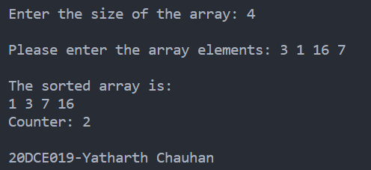

**ANALYSIS TABLE:**

|  |  |  |  |
| --- | --- | --- | --- |
| Input | Bubble Sort | Selection Sort | Insertion Sort |
| 1 | 0 | 1 | 0 |
| 3 | 2 | 3 | 2 |
| 5 | 1 | 5 | 4 |
| 6 | 9 | 6 | 3 |

**GRAPH**:

**CONCLUSION:**

In this practical I learn the comparison between selection sort, bubble sort and insertion sort. We also studied their worst, best and average case scenarios and accordingly we plotted the graph.